The following instructions will take you through the Slotted Box simulation. This simulation is a simple introduction to using EMA3D with CADfix, and also provides a direct opportunity to compare with experimental results that have been published in the IEEE [1]. Make sure you include the source file “gauss_2ghz.dat” in the same directory as your FBM file.
- Open CADfix and save a new document as ‘slotted_box_1.fbm’.
- Before entering the EMA3D toolbox, we will create our geometry using CADfix primitives and other native features. In the upper left hand corner click on the ‘Tools’ drop-down bar, navigate into the ‘Toolbox’ and then select ‘Primitives’, as shown:
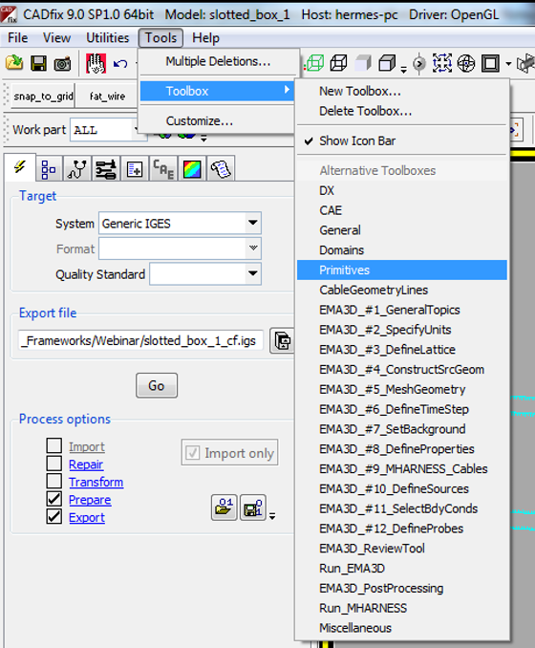
- In CADfix, we always work with sets so that we can easily track what we have built and later assign materials to specific entities. Open a new set called ‘box1’ by typing ‘seto box1’ in the command prompt, and then hitting enter, as shown:
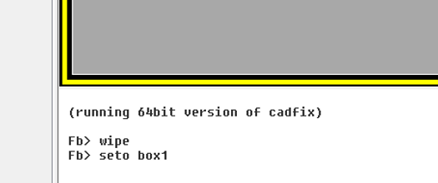
- Next, take advantage of the CADfix primitives to create a box. The box will be used to simulate radiated emissions from a slot. The size of the box and subsequent geometric entities that we create follow those from [1], since we intend to make a direct comparison of our simulation results to experimental values. Click on the right hand side of the screen to select the ‘Make Box’ Primitive. Enter the following values, then click ‘Apply’ and close the window:
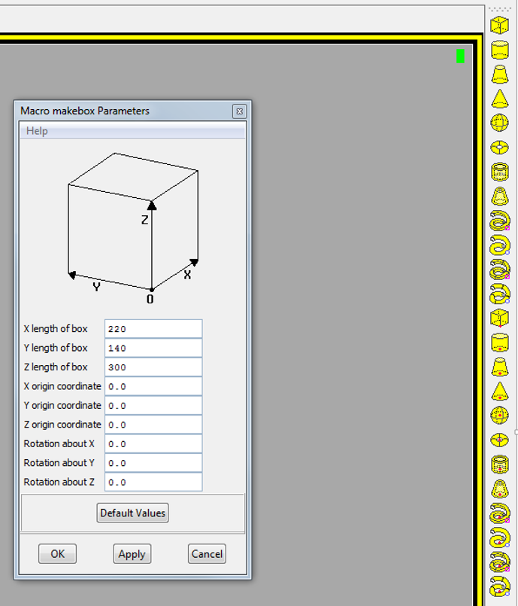
- Close the set ‘box1’ by typing ‘setc box1’ in the command prompt and then hit enter. View the geometry you have just created by typing ‘plus si box1 c’ and then enter. Then press ‘plus l box1 k’ and enter. You will have the following image:
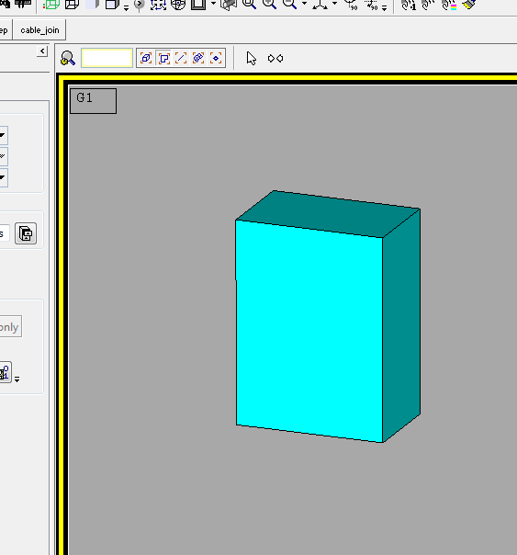
- There are a few more geometrical entities that must be made for this simulation, including two lines and a point. One of the lines will serve as the antenna source for our problem, and the other will acts as a slot for the emissions from the box. The point provides a location in space at which the emitted fields can be obtained during the EMA3D simulation.
Open the set ‘source1’ by typing in the command window: ‘seto source1’, as we have done previously for other sets. Make two points by typing in the command window ‘pnt ! 170 140 150’ and then ‘pnt ! 170 0 150’.
- Wipe the screen by entering ‘wipe’ and then look at the points you just made by typing ‘plus pa source1 b’
- The next step involves using the CADfix build tab and the Figure below can be consulted for guidance. Click the build tab (circled in red), and then click on ‘Create/edit lines’, as shown. Make sure to highlight the box ‘Pnt 1’ and then click on one of the points you just created, as seen. Do the same for ‘Pnt 2’ and your other point. Then click ‘Apply’.
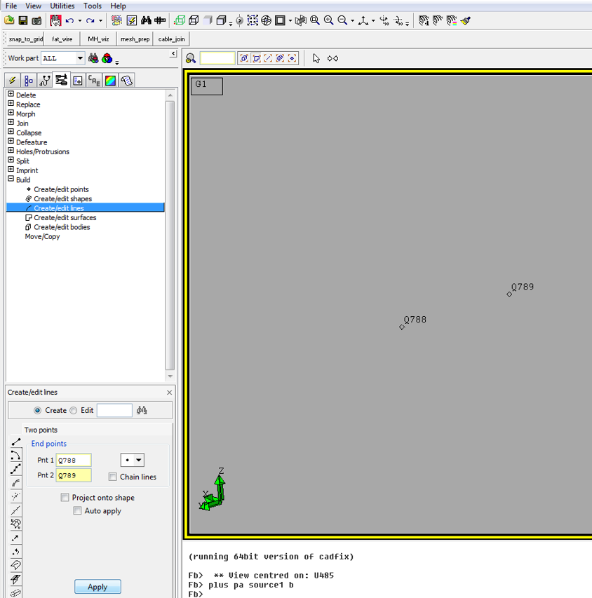
- You should have created a new line in the set ‘source1’. This can be checked by typing ‘prnt se source1’, or by plotting ‘plus la source1 r’, for example. Once you are satisfied that the line has been generated, close the set by entering ‘setc all’.
- Make another line in a set called ‘slot1’ by following the same steps 6-8 again. The line should have end points at (0,5,90) and (0,5,210). Be sure to close the set after you are satisfied with the new line you have generated.
- For our last geometry task, open the set ‘probe1’ and enter ‘pnt ! -3000 70 150’, to create the point at which the E-field will be evaluated. Then enter ‘setc all’.
- Now that our model geometry is built, we can begin to work our way through the EMA3D toolbox and will reference it in what follows. Begin with ‘SpecifyUnits’, as seen below. At each stage of the toolbox, options will appear on the right hand side of the CADfix GUI. Click on ‘Units’ and ensure you are working in millimeters. The click ‘OK’.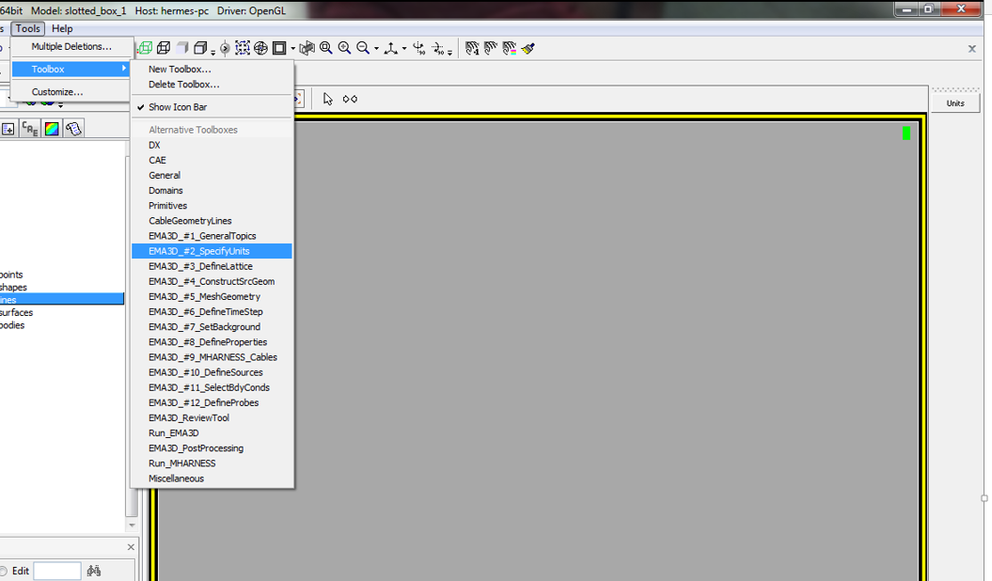
- Next, select ‘DefineLattice’ and click on ‘ConLatt’. Enter the following parameters and click ‘OK’.
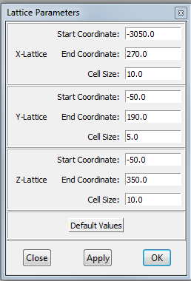
- Before moving to the next step, let’s have a look at our problem space to ensure everything looks right. Make sure the screen is clean by entering ‘Wipe’. Now enter the following graphics commands:
plus si box1 b, plus g box1 k, plus la source1 y, plus la slot1 r, plus pa probe1 m, plus late
and check that your screen looks like the figure (the specific names of point and lines will be different).
- Next we select the EMA3D tool ‘MeshGeometry’. Click on ‘Setup’ and then ‘Mesh’. Check that your geometry meshed correctly by typing ‘plus n all y’. You may also wish to check the nodes of the individual sets separately by replacing ‘all’ with the specific set name. The mesh should look as follows:
- Continue to work your way through the EMA3D toolbox. Select the ‘DefineTimeStep’ option and select ‘TimeStep’ and then enter 1.0e-011 for the Timestep and 100001 for the Number of Timesteps. Click OK.
- Next, Select the EMA3D tool ‘Define Properties’. Click on the Property icon on the right side of the GUI, and in the EMA3D Property Editor select ‘New’. Use the drop down menu to select PEC Surface, assign it the name PECS, and click OK, as shown.
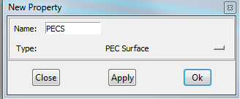
We will need to define two additional material properties for this simulation. Repeat the previous steps, this time selecting ‘Thin Gap’ from the drop down menu, and naming the property TG1. The GUI will ask you to select the width of the gap, which you should choose to be 1.0 model units. Lastly, select ‘Thin Wire’ from the drop down menu and name the property THIN1. The GUI will ask you for properties related to the thin wire. The following values are appropriate:
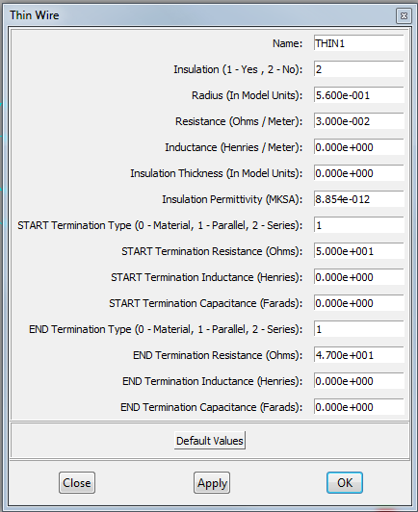
- Next, we need to assign the materials. On the ‘EMA3D Property Editor’ GUI, there is an option to ‘Assign’. Assign the property ‘THIN1’ to the set ‘source1’ as seen:
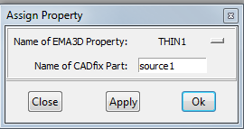
Do the same step twice more, assigning PECS to box1, and TG1 to slot1.
- Next we move to the EMA3D tool ‘DefineSources’. Select the option for ‘ThwVol’. You will notice one of the GUI entries asks for ‘Single Node to be Loaded’. To determine this Node, enter the following commands: ‘wipe’, ‘plus na source1 y’. Now, zoom in to look at the Nodes and note the number of the Node next to furthest along the y-axis. For instance, in the figure below the Node would be ‘333’:
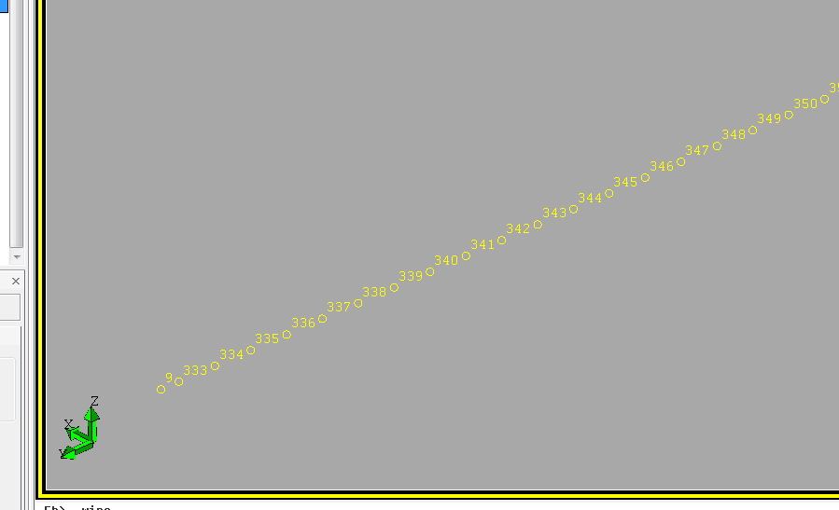
Now enter the following information into the GUI, replacing ‘333’ with whichever number if right for you:
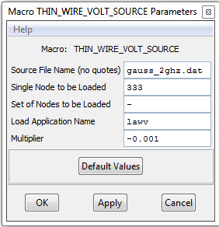
- Next, we select the boundary conditions. Use the EMA3D tool ‘SelectBoundConds’ and open the ‘Bound’ option. Select PML All and click Apply:
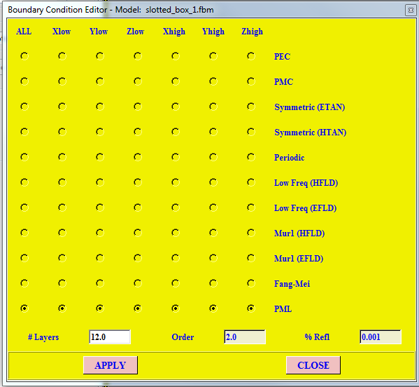
- We are now ready to define the probes. Navigate to the EMA3D tool ‘DefineProbes’ and click on the Slice option toward the bottom. The slice probe provides a graphical output of specified field quantities in a slice of the problem space. This information can give the user intuition about the physics of the simulation. Type ‘SETA SLPR1 PROBE1’ in the command line and hit enter. Enter the information as seen below, replacing ‘Q792’ with the name of your point in the set ‘SLPR1’. You can check this point in the console by entering ‘prnt p slpr1’ and noting the name of the point displayed (you can also ‘plus pa slpr1 r’) to view it on the geometry window. Fill in the slice probe window as shown below:
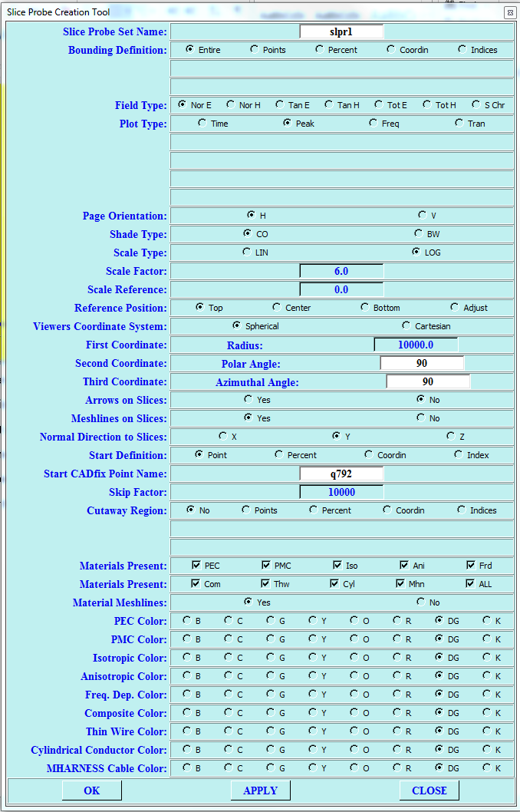
- We also need to set a E-field pobe. To do that we need to specify that the point in set ‘probe1’ is to meausre the y component of the electric field. Click on the ‘New 2’ icon on the right hand side and use the entries in the figure below to guide you and click OK
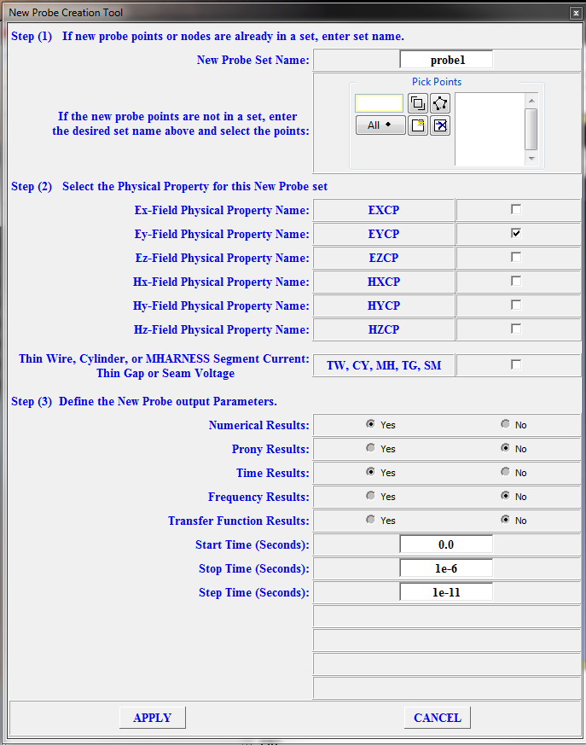
- We are now ready to generate our EMA3D input file. Go to the EMA3D toolbox item ‘ReviewTool’ and click on Review. Verify the items look consistent with the steps above. When you are satisfied, click ‘Create EMA3D Input File’ with the following selections. Click OK.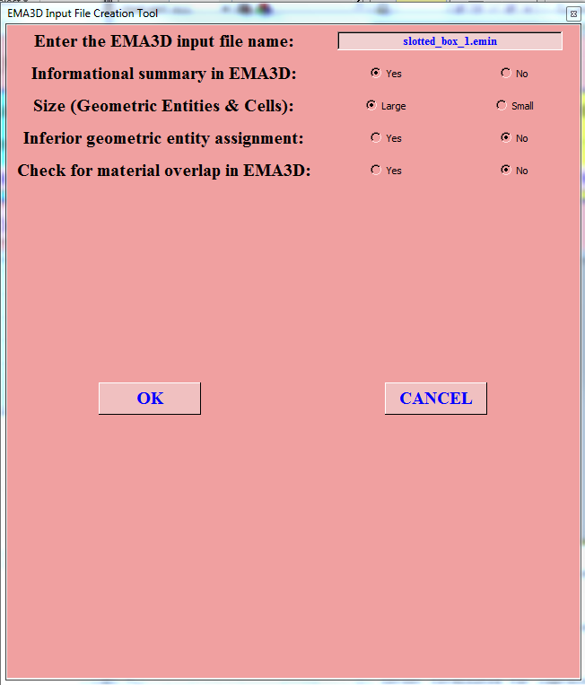
- The EMA3D input file should be created in the same directory as your CADfix file and we are almost ready to begin the simulation.
- Select the ‘Run_EMA3D’ option. Browse the for ‘slotted_box_1.emin’ and make sure the radio button ‘Run New EMA3D Simulation’ is selected. Click ‘Run EMA3D’.
- The simulation should take about an hour depending on your machine. When the simulation finishes, take a look at the postscript image generated by the slice probe, which should look like the following:
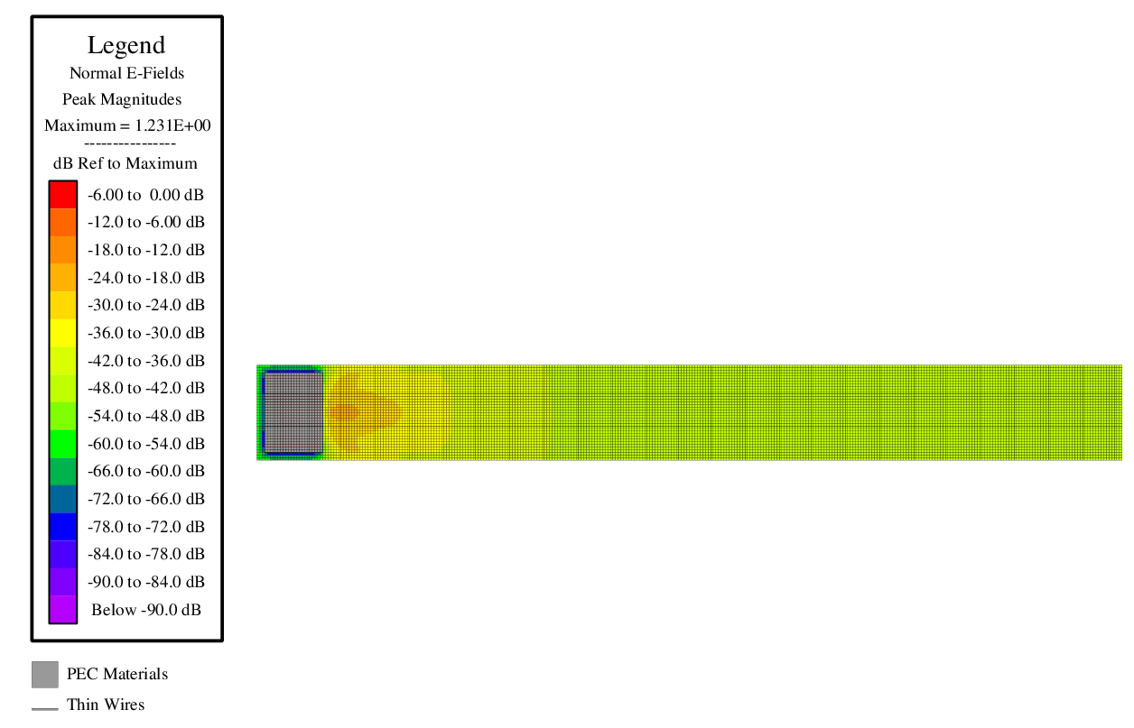
- To compare to the Figure 4(b) from reference [1], run the provided EMA processing script, sim1_plot.py. This script needs to be in the same directory as the other files used for the simulation, and requires Python version 3 with NumPy, SciPy, and Matplotlib. The figure should look as follows:
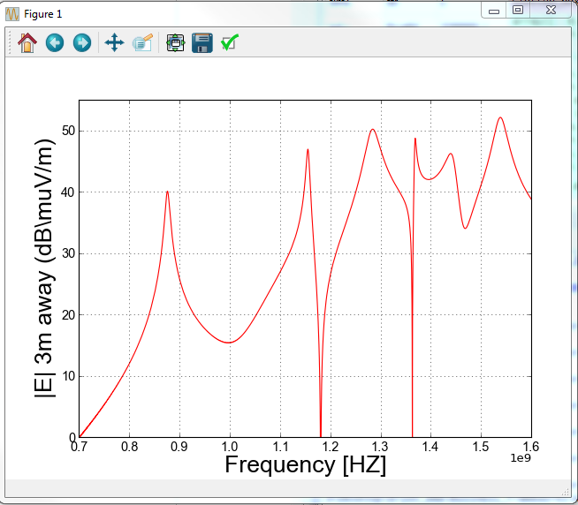
References
- M. Li, J. Nuebel, J. L. Drewniak, R. E. DuBroff, T. H. Hubing, T. P. Van Doren, “EMI from Cavity Modes of Shielding Enclosures – FDTD Modeling and Measurements,” IEEE Transactions on Electromagnetic Compatibility, Vol. 42, No. 1, pp. 29 – 38, Feb. 2000

